FY23 Board Officers  Chair of the Board  Jeff Rayfield  Chair Elect  Jane Kaiser  Vice Chair, Business Finance  Becky Knezevich  Vice Chair, Operations  Joy Voss  Vice Chair, Governance  Ed Balmes  Secretary  Casey Gundlach  Vice Chair, Development  Chrissy Teske  Chief Executive Officer  Clint Bolser  Board of Directors  Mani Amin  Jennifer Bierling  Richard Chong  Andrew Gillentine  Melissa Jones  Armando Siliceo-Roman  Kelli Williams  Raychel Proudie  Jamey Shields | November 4, 2022  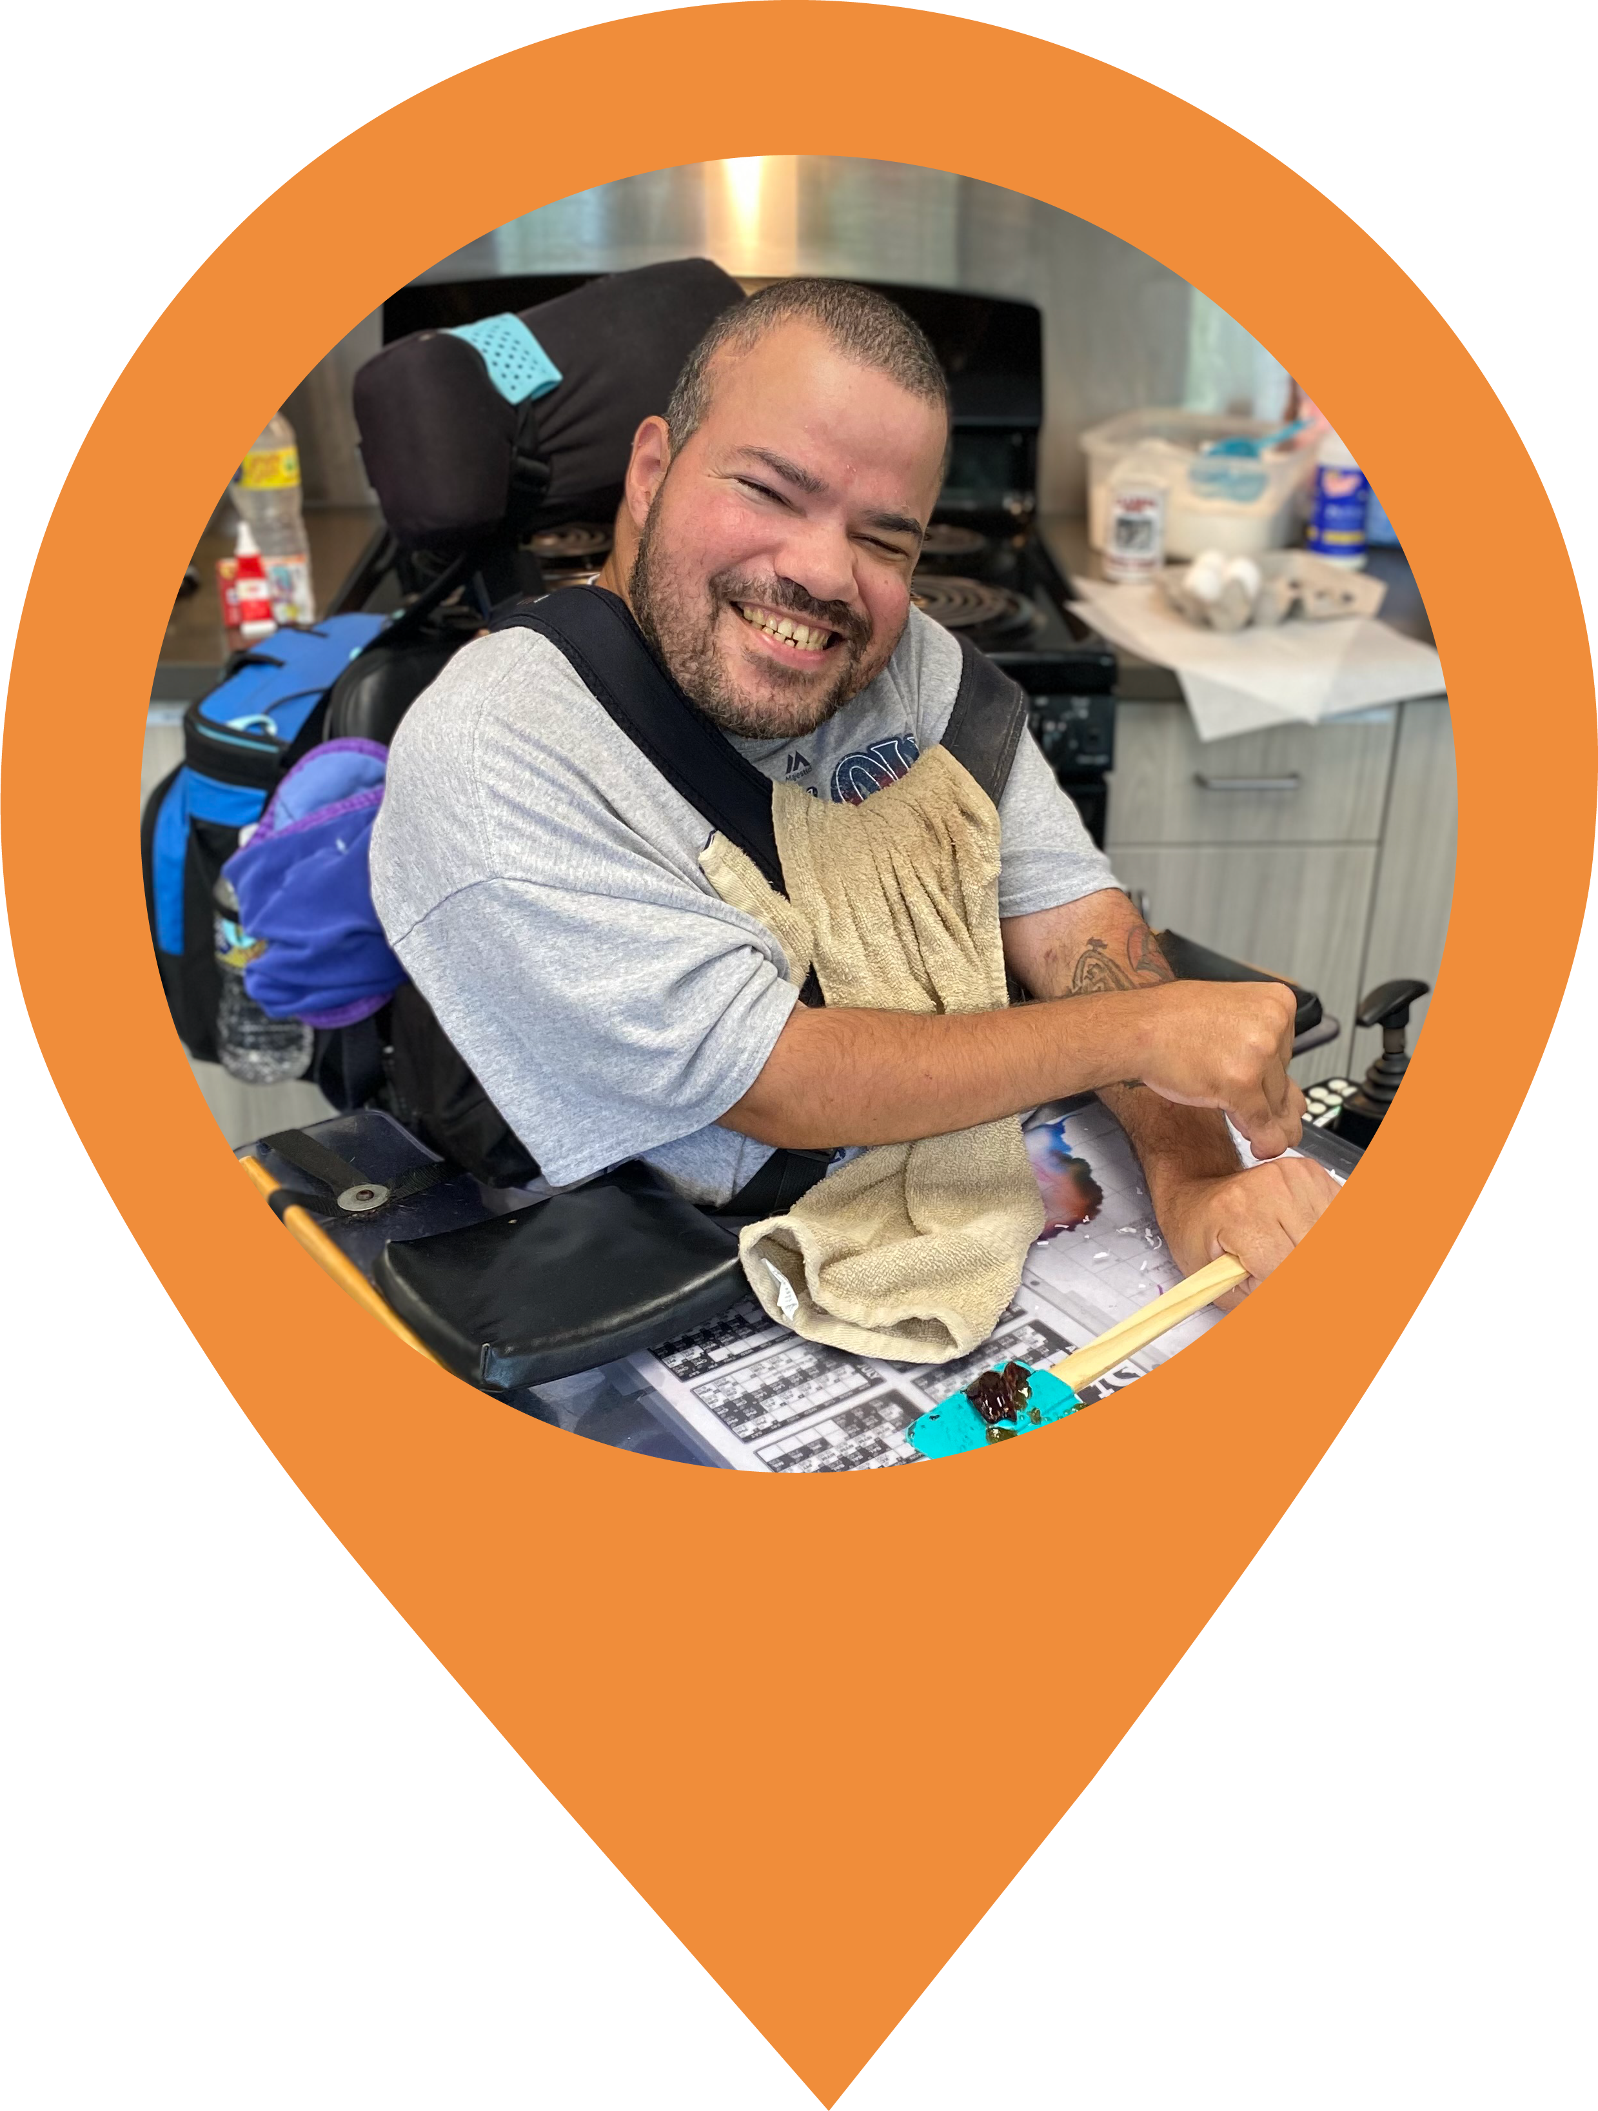  <Company>  c/o <Contact>  <Address>  <City, State, Zip>  <Salutation>,  Over the last 69 years, UCP Heartland has stayed true to its heart. We continue to provide the support necessary for a successful and meaningful life for children and adults living with differing abilities. We are committed to give the extraordinary care and support that people need to thrive in school, at home, at work, and in their community.  I am inviting you to UCP Heartland’s “Follow Your Heart” Annual Gala on Saturday, February 25th, 2023, at the Hilton Frontenac. With over 300 guests in attendance, this is our biggest revenue source for the year with a cocktail hour, delicious dinner, and unforgettable silent and live auctions. Please  “Follow Your Heart” and support our silent auction that evening by  donating for tickets to a St. Louis Cardinals game in the 2023 season to  support people with disabilities here in St. Louis.  Your sponsorship helps people like Vincent. Vincent has been making huge strides this past year in our Adult Day Services Program. He has become an active participant in UCP Heartland self-advocacy efforts, and he has a dream of living independently. Vincent began to advocate for himself by meeting one on one with his Support Coordinator to develop an action plan with small steps in achieving his dream. Vincent’s action plan included short stays at our beautiful Respite home in the heart of Webster Groves. Our Respite home has 24/7 personal care assistance and gives him the opportunity to see what it is like not living with his family. He was nervous the first night he was away from home, but he quickly adjusted. Vincent enjoys going to the Respite house so much that he now sends emails requesting Respite services on his own. He told us, “My favorite things at Oak Tree are the food, the staff, and being on my own”. Vincent and his family are amazed how much progress he has made, and he is excited to keep reaching his full potential.  As the cost- of-living increases and as caregivers age, families are relying on services now more than ever. Please join us in providing the highest quality of care and services to our clients. Together, we can change the way the world sees people with disabilities and our communities become rich with diversity as we incorporate our clients into every facet of society.  If you have any questions, please contact Kevin Amstutz, Major Gifts Officer, at 636-779-2253 or via email at Amstutzk@ucpheartland.org. On behalf of UCP Heartland and the amazing individuals we serve, thank you for your consideration.  Sincerely,  Clint Bolser  Executive Director  Missouri NAP tax credits may be available for your donation. Please let us know if you are interested.

Corporate Office: 4645 LaGuardia Drive | St. Louis, MO 63134 (314) 994-1600

