November 16, 2022
<Company>
c/o <Contact>
<Address>
<City, State, Zip>
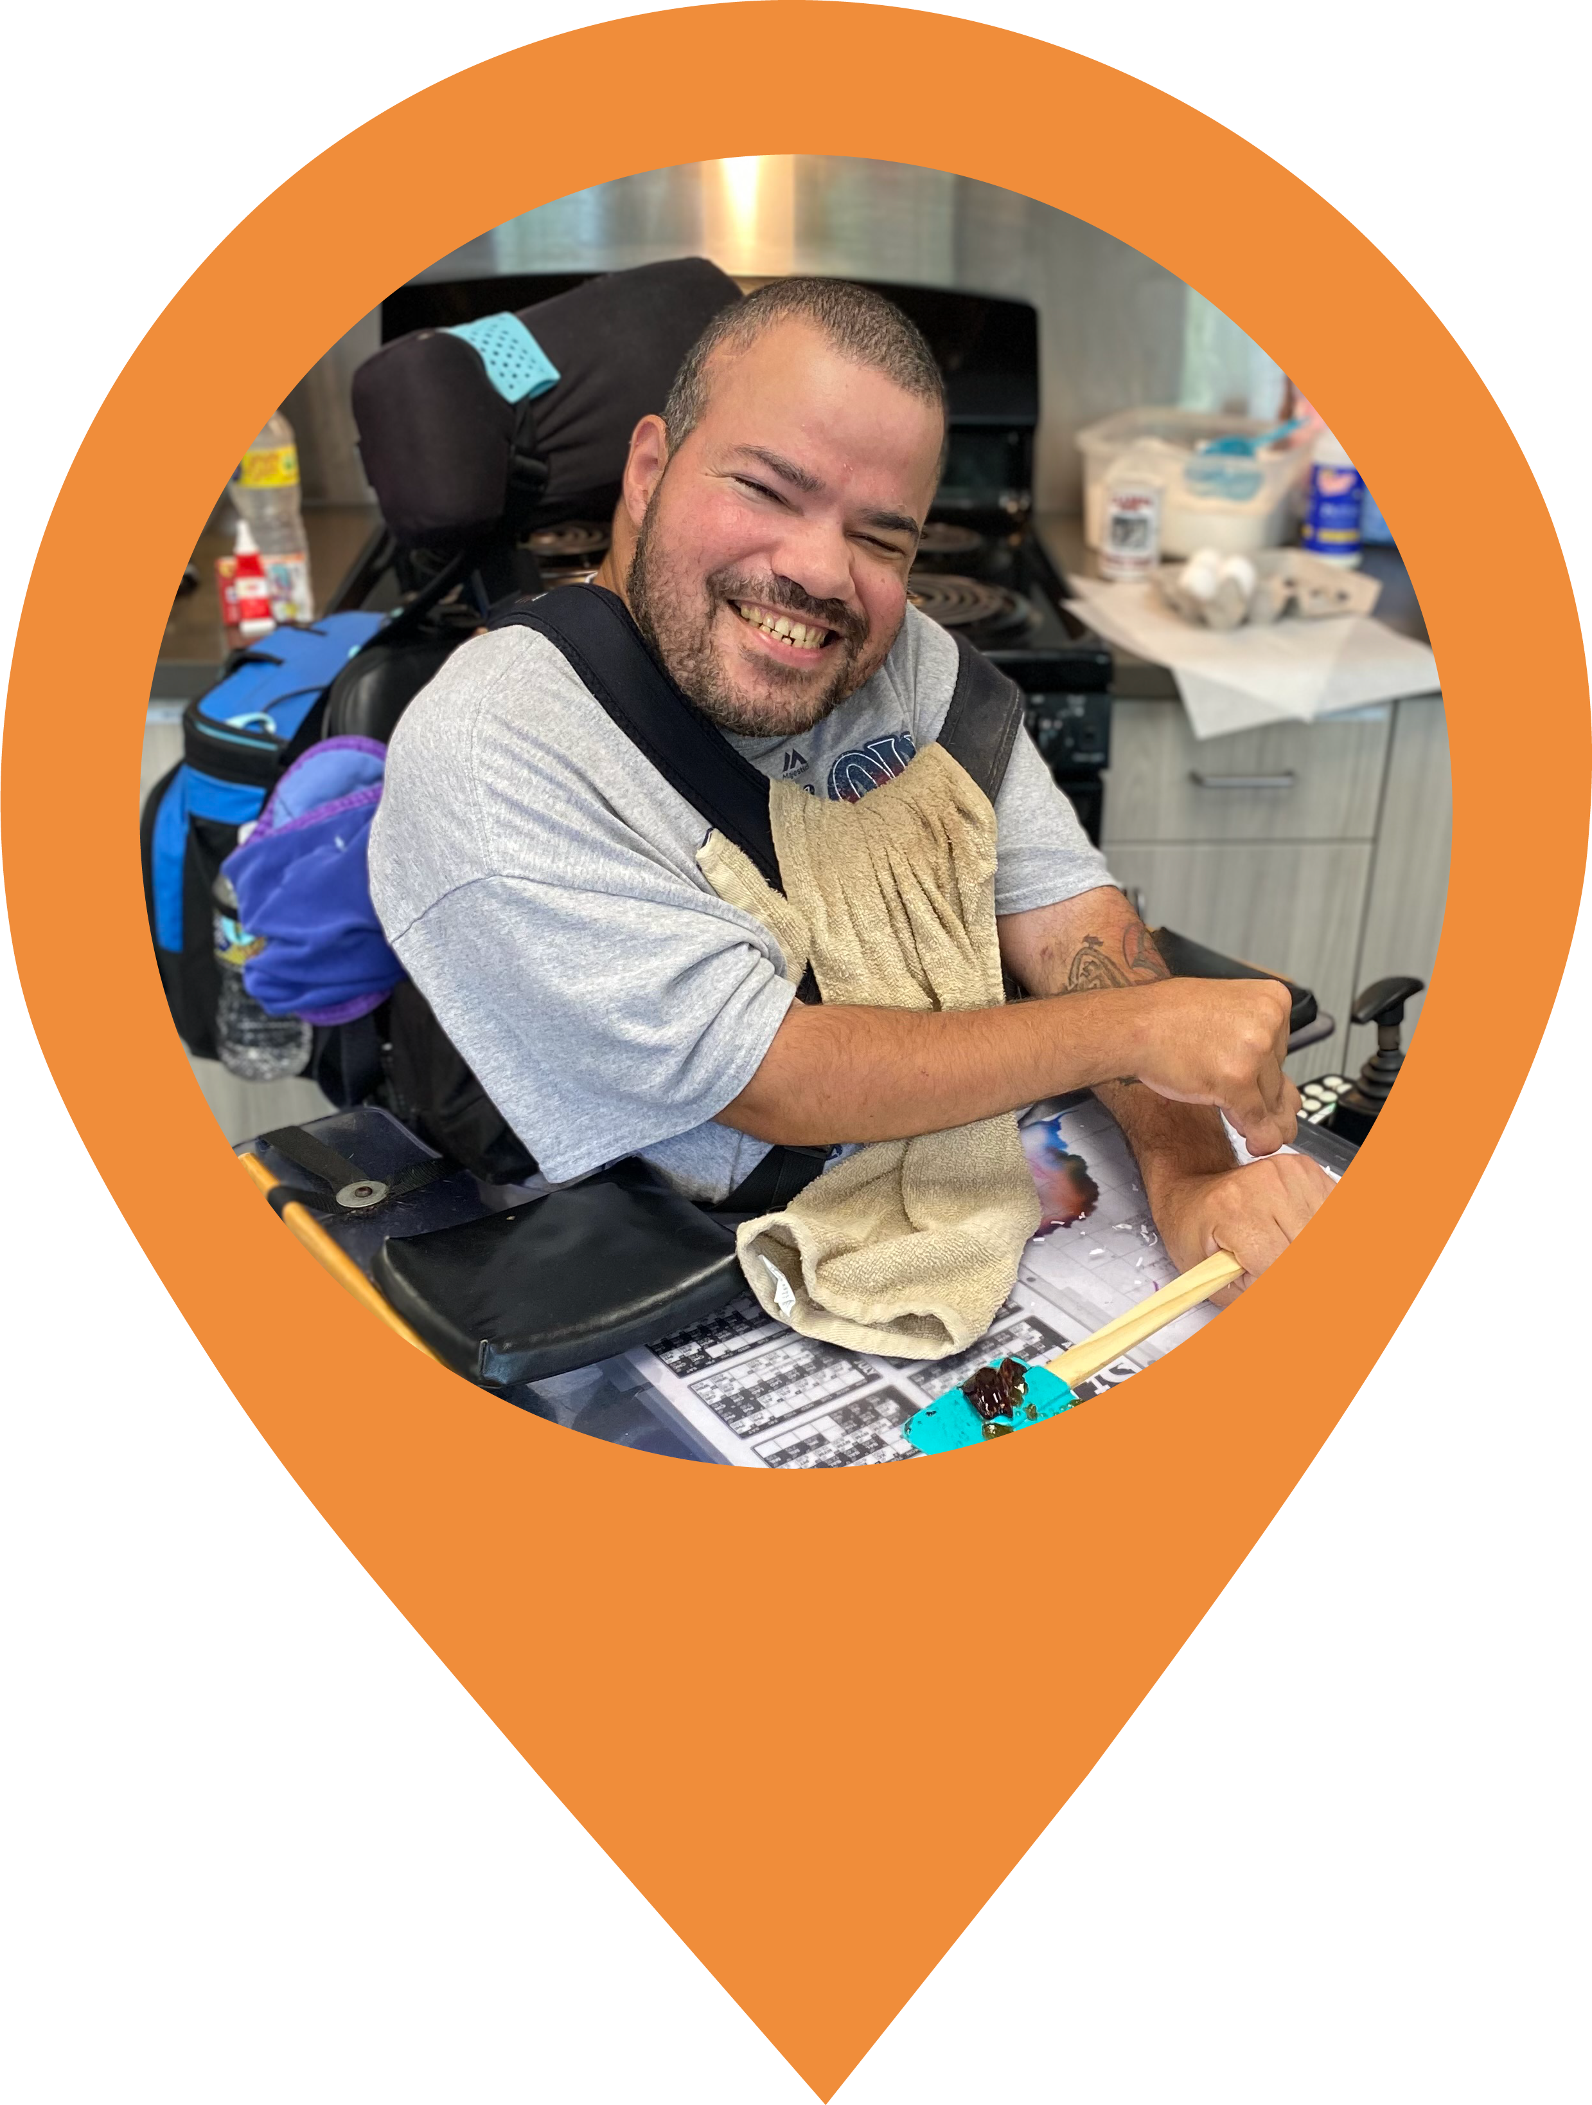
<Salutation>,

As you may know, I am passionate about supporting the needs of those who live with disabilities in our community. In order to make a difference, I’ve committed to being a member of the Host Committee for the 2023 UCP Heartland Gala. Over the last 69 years, UCP Heartland has stayed true to its heart by providing the support necessary for children and adults with differing abilities to live a successful and meaningful life. They are committed to giving the extraordinary care and support that people need to thrive in school, at home, at work, and in their community.

I am inviting you to UCP Heartland’s “Follow Your Heart” Annual Gala on Saturday, February 25th, 2023, at the Hilton Frontenac. That night, we will be honoring Brian & Nina Murphy for their impact on both UCP Heartland and the community at-large. Please join me in attending the Gala in February. Aside from changing hundreds of lives, you will also enjoy a cocktail hour, delicious dinner, and experience unforgettable silent and live auctions.

Your participation helps people like Vincent. Vincent has been making huge strides this past year in the Adult Day Services Program. He has become an active participant in UCP Heartland’s self-advocacy efforts, and he has a dream of living independently. Vincent began to advocate for himself by meeting one-on-one with his Support Coordinator to develop an action plan of small steps toward achieving his dream. Vincent’s action plan included short stays at our beautiful Respite House in the heart of Webster Groves. Our Respite House has 24/7 personal care assistance and gives him the opportunity to see what it is like not living with his family. He was nervous the first night he was away from home, but he quickly adjusted. Vincent enjoys going to the Respite house so much that he now sends emails requesting Respite services on his own. He told us, “My favorite things at Oak Tree are the food, the staff, and being on my own”. Vincent and his family are amazed at how much progress he has made, and he is excited to keep reaching his full potential.

As the cost- of-living increases and caregivers begin to age, families are relying on services now more than ever. Please join us in providing the highest quality of care and services to our clients by becoming a sponsor for UCP Heartland’s Gala. Together, we can change the way the world sees people with disabilities and create richly diverse communities with our clients’ incorporation in every facet of society.

If you have any questions, please contact Kevin Amstutz, Major Gifts Officer, at 636-779-2253 or via email at Amstutzk@ucpheartland.org. On behalf of UCP Heartland and the amazing individuals we serve, thank you for your consideration.

Sincerely,

Your Name
Your Title

